**FINAL INDIVIDUAL PROJECT**

1. **Link to the GitHub repository**

<https://github.com/dhavaldp96/FIP.git>

1. **Screenshots**
2. ***YOUR*** project showing postman listing all records

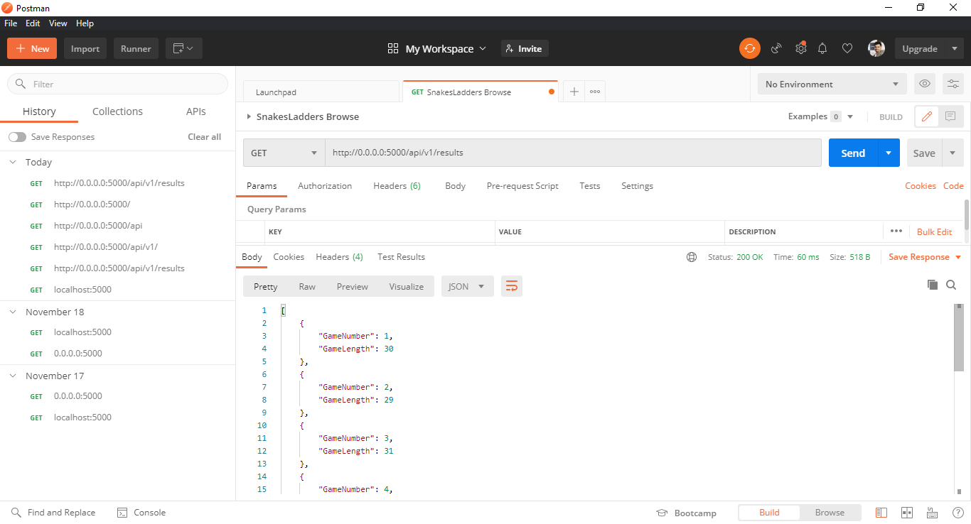

1. ***YOUR*** project showing postman showing one record with a get request
2. ***YOUR*** project showing postman creating a record by showing the post request and the results in the record listing

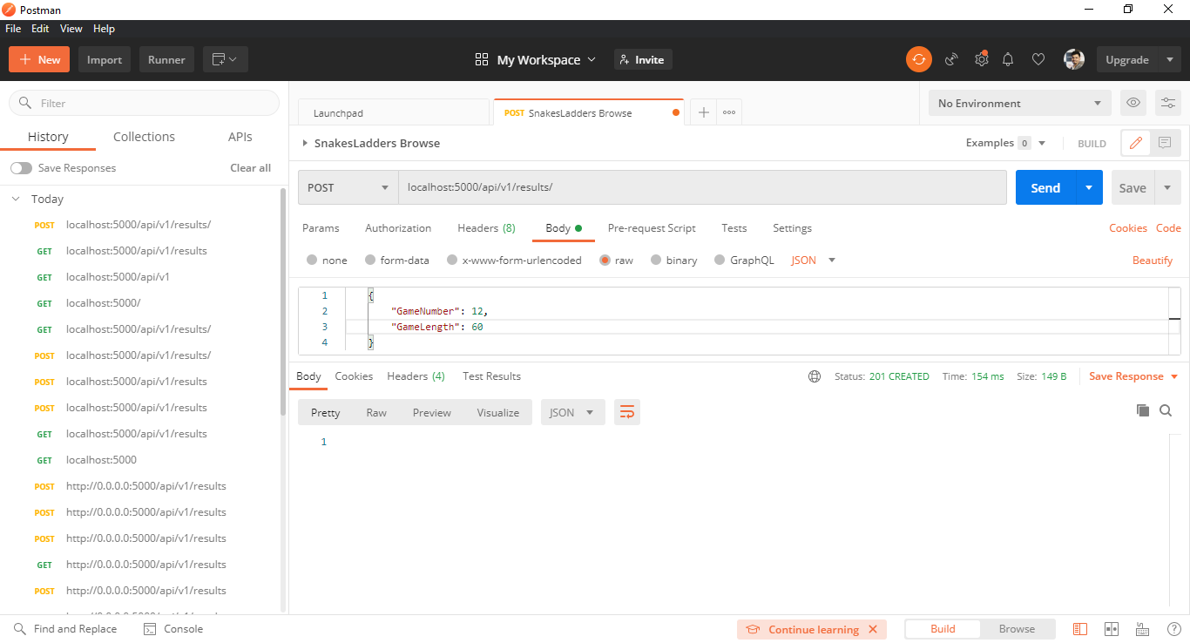

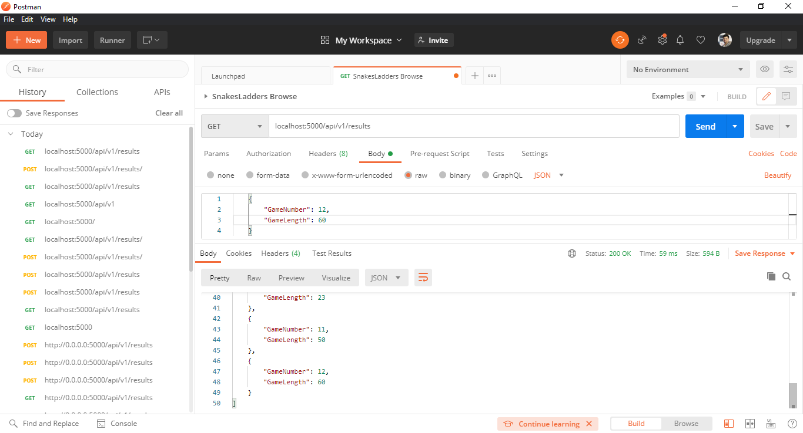

1. ***YOUR*** project showing postman edit a record by showing the put request and the results in the record listing
2. ***YOUR*** project showing postman delete a record by showing the delete request and the results in the record listing